|  |
| --- |
| **Crazy Game Creation**  Crazy-PNG-File-420x272.pngTitle.png  The Return of the Dead |
| Version #0.1  All work Copyright © 2017 by XX Games.  All rights reserved |
| **Haydar Shariff - 300 828 076**  **Adalberto Cuevas de Paula - 300 917 462**  **Ostap Hamarnyk - 300 836 326** |
| |  | | --- | | **August 04th 2017** | |

Table of Contents

[**2 Version History 4**](https://docs.google.com/document/d/1Ov1D96olUs5XdZ8CH8h-okyVJfZDQAbFmEgPCEXpPxA/edit#heading=h.ocazdecnrcfd)

[**3 Game Overview 6**](https://docs.google.com/document/d/1Ov1D96olUs5XdZ8CH8h-okyVJfZDQAbFmEgPCEXpPxA/edit#heading=h.1kqfndr9l3ds)

[3.1 Game Play Mechanics 6](https://docs.google.com/document/d/1Ov1D96olUs5XdZ8CH8h-okyVJfZDQAbFmEgPCEXpPxA/edit#heading=h.ocv8lx2yptgm)

3.2 Camera 6

[3.3 Controls 7](https://docs.google.com/document/d/1Ov1D96olUs5XdZ8CH8h-okyVJfZDQAbFmEgPCEXpPxA/edit#heading=h.dj0ubvbq2732)

[3.4 Interface Sketch 8](https://docs.google.com/document/d/1Ov1D96olUs5XdZ8CH8h-okyVJfZDQAbFmEgPCEXpPxA/edit#heading=h.gjdgxs)

[3.5 Menu and Screen Descriptions 9](https://docs.google.com/document/d/1Ov1D96olUs5XdZ8CH8h-okyVJfZDQAbFmEgPCEXpPxA/edit#heading=h.myu4hbkvpt12)

[3.6 Game World 9](https://docs.google.com/document/d/1Ov1D96olUs5XdZ8CH8h-okyVJfZDQAbFmEgPCEXpPxA/edit#heading=h.4urjwz3s5dph)

[3.7 Levels 10](https://docs.google.com/document/d/1Ov1D96olUs5XdZ8CH8h-okyVJfZDQAbFmEgPCEXpPxA/edit#heading=h.w3ibg5rbnmpu)

[3.8 Game Progression 10](https://docs.google.com/document/d/1Ov1D96olUs5XdZ8CH8h-okyVJfZDQAbFmEgPCEXpPxA/edit#heading=h.q26mtw4m8geq)

[3.9 Enemies 10](https://docs.google.com/document/d/1Ov1D96olUs5XdZ8CH8h-okyVJfZDQAbFmEgPCEXpPxA/edit#heading=h.3eo77si4xh7h)

[3.10 Weapons 11](https://docs.google.com/document/d/1Ov1D96olUs5XdZ8CH8h-okyVJfZDQAbFmEgPCEXpPxA/edit#heading=h.4el9efla0ifl)

[3.11 Items 12](https://docs.google.com/document/d/1Ov1D96olUs5XdZ8CH8h-okyVJfZDQAbFmEgPCEXpPxA/edit#heading=h.qefmg4gfecnm)

[3.12 Abilities 12](https://docs.google.com/document/d/1Ov1D96olUs5XdZ8CH8h-okyVJfZDQAbFmEgPCEXpPxA/edit#heading=h.m0nt41o8nhx7)

[3.13 Vehicles 12](https://docs.google.com/document/d/1Ov1D96olUs5XdZ8CH8h-okyVJfZDQAbFmEgPCEXpPxA/edit#heading=h.pd6snn3z3x3r)

[3.14 Art / Multimedia Index 13](https://docs.google.com/document/d/1Ov1D96olUs5XdZ8CH8h-okyVJfZDQAbFmEgPCEXpPxA/edit#heading=h.ay5nvwyemj5t)

[3.15 Design Notes 14](https://docs.google.com/document/d/1Ov1D96olUs5XdZ8CH8h-okyVJfZDQAbFmEgPCEXpPxA/edit#heading=h.hefm1nmhj2f)

[3.16 Future Features 14](https://docs.google.com/document/d/1Ov1D96olUs5XdZ8CH8h-okyVJfZDQAbFmEgPCEXpPxA/edit#heading=h.g9dug7w2cus5)

**Version History**

0.1 Setup of the graphic and game architecture.

0.2 Create the game first screen menu.

**Game Overview**

*The last Zombies are on your way to the cure from the “Death disease”, it is time for you and your team to take action and with your arsenal set killer turrets at a strategic location, and get those to kill zombies and clear the area around for the safe approach.*

*The infection keeps spreading until you apply the cure all over the world. Be the first to help Warriors of Light to kill the walking dead and rescue the world!*

**Game Play Mechanics**

*It is a tower defense game; the player needs to set up towers in way that Zombies waves are eliminated before they get into the city. Player can place towers in the specified locations of 4 different types. You are given a certain amount resources and to get more you will need to acquire more money. Each tower can be upgraded up to 3 levels. You can also upgrade the towers to make them more strong and hit Zombies at a farther range. Once the Zombies start entering in to your city, you will start losing points for every of them that have access to it, once you get into 0 points you will lose the game. Also, there are bonuses which can help player to pass the level.*

**Camera**

*The camera is a top-down camera*

**Controls**

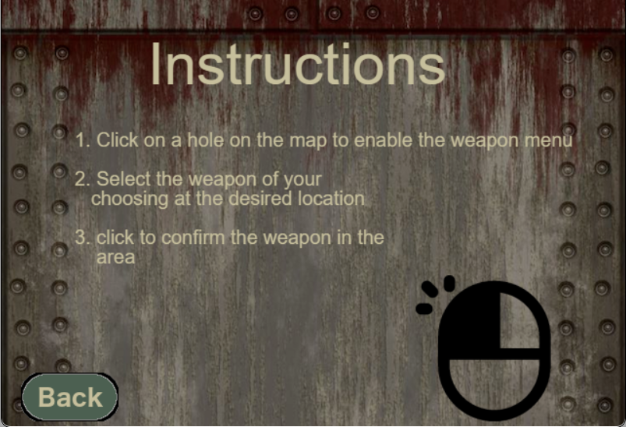The controls are very basic as this game is more automated as the zombies come in waves and they move by themselves. The only actual movement that a player makes is to choose specific weapons by pressing on a selected area or tower station. For the most part the controls are straightforward and tend to just common sense

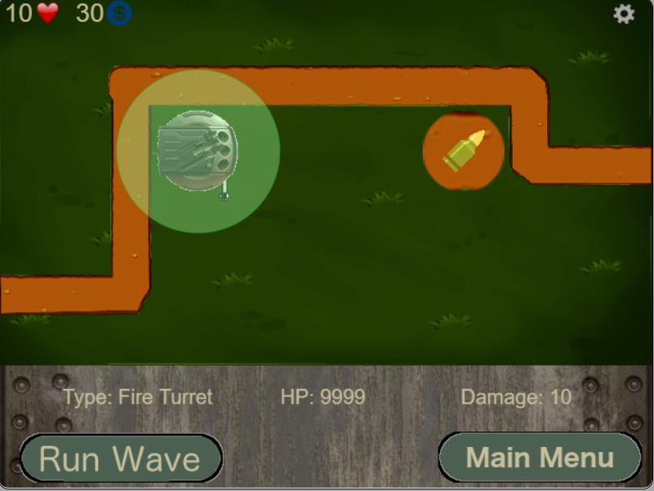

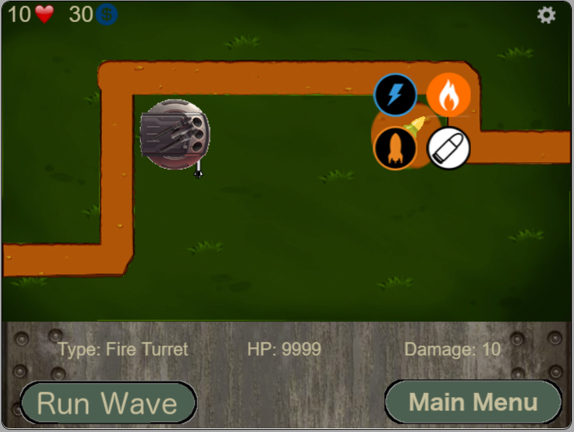

*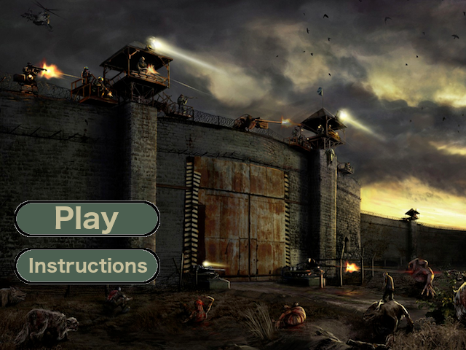***Interface Sketch**

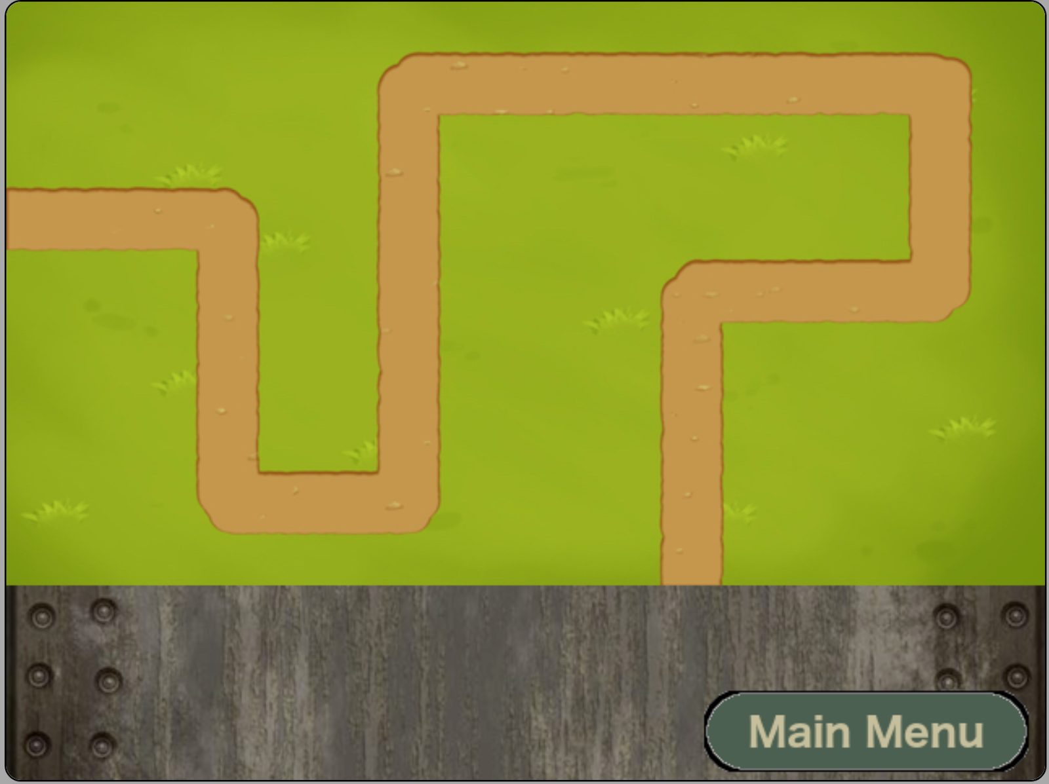

**Menu and Screen Descriptions**

*As of now we have implemented a Play and Instructions button on our main page. The main page just has the logo of our game and a tower army defense background. When you press play you land on our 1st level background with the option to go to the main menu. The instructions page has instructions on how to play our game.*

**Game World**

*The game starts in Toronto, Canada and the characters want to reach Alberta to find the desired scientist. There are three different locations for now which are city, field and city in winter conditions. The environment is dark to make user feel the real fear and pressure that the characters feel.*

**Levels**

The levels will vary as they will mostly be differentiated by the number of zombies, the amount of waves of Zombies, and the speed of Zombies. There will also possibly be a larger or more complicated map, depending on the timeframe given.

**Game Progression**

Game progression is based on your ability to withstand waves of Zombies trying to enter the city with the tower defenses that you equip and implement.

**Non-player Characters**

The tower are your allies as they act as the only real defender in the game for you. These towers are customizable and as stated previously can be upgraded to be made stronger and can be equipped with 4 different types of guns.

**Enemies**

*Zombies that try to get in the city and infect it population.*

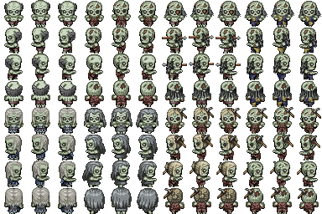

**Weapons**

*(Describe any weapons available to the user)* 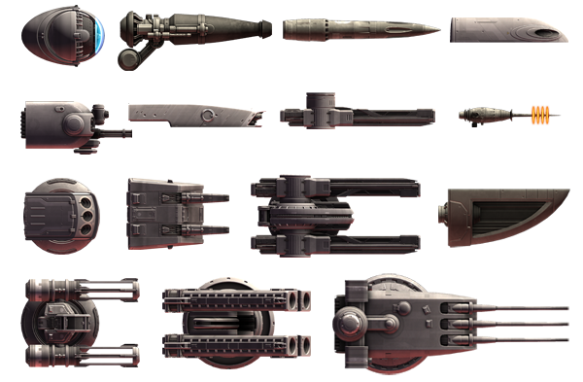

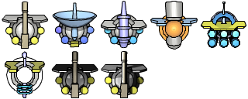

**Items**

*(Describe any in-game items that can help or hinder the user)*

**Abilities**

**Vehicles**

**Script**

**Scoring**

**Puzzles/Mini-games**

**Bonuses**

**Cheat Codes**

**Sound Index**

*(Include an index of all your sound clips)*

**Story Index**

*(Outline your game story here)*

**Art / Multimedia Index**

***\*Buttons***

*FbackBtn.png*

*instructionsBtn.png   
mainMenuBtn.png  
playBtn.png*

***\*Images***

*bullets.png  
gameBackground.png  
instructionsBackground.png  
mouseIconLeft.png  
turrents_sprite.png  
turrets_lazer.png   
zombies.png*

***\*Maps***

*1.jpg   
10.jpg   
11.jpg   
12.jpg   
2.jpg   
3.jpeg   
4.jpg   
5.jpg   
6.jpg   
7.jpg   
8.jpg   
9.jpg*

**Design Notes**

*(Include additional design notes here)*

**Future Features**

*Things that must be done are:*

* *Select (or draw) weapons images and animations (shooting, turrets rotation etc.)*
* *Create sprite sheets w/ enemies & implement their animation (walking in four directions, dying etc.)*
* *Create maps*
* *Implement first two game levels*
* *Modify game interface (add menu controls to build turrets, access game settings and home screen)*
* *Pause and Play*
* *sound effects and mute options*
* *possible upgrades for weapons*